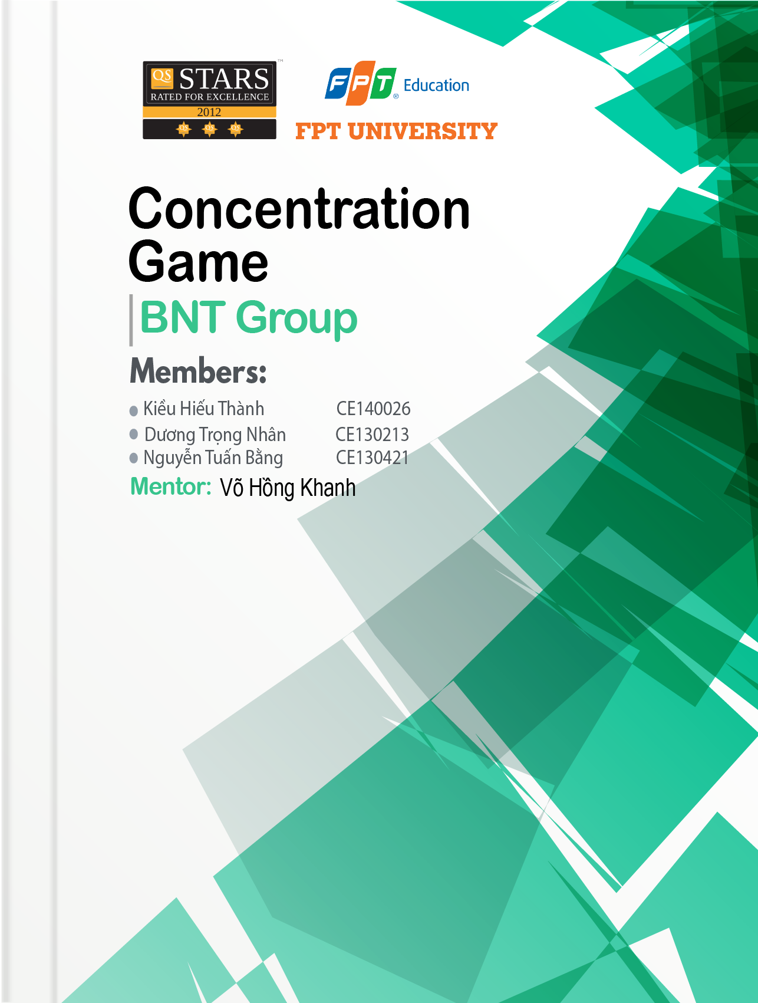

Table of Contents

1. Problem Definition 3
2. User Requirements 4

1. Functions 4

2. System Requirements 4

1. Roles 5
2. Schedule 6
3. Design Pattern 8

1. Program Interface 8

1. Execution Flow 12

1. Algorithm Diagram 12

1. Maintenance and Updating 13
2. Check List 14

# Problem Definition

Concentration game is a memory card-based game. To win this game, players have to clear all folded cards. However, players can only unfold 2 cards at a time so they have to remember card’s picture and position in order to beat the game in the shortest time. The game uses a simple interface suitable for all ages. In-game images are added by each developer according to a certain theme. Over the time, due to its easy-to-play and brain-training gameplay, it became popular and has been remade in various version by many developers.

Ours game will have these functions:

* Difficulty: There will be 3 difference difficulty: An Easy Mode which a baby can win, A Normal one and A Hard Mode that only pro players can beat it.
* Custom Mode: Player can adjust number of rows, number of collums and timer.
* Themes: Player can choose the game’s theme: PvZ, Animal, Fruits and Vegetables, etc.
* 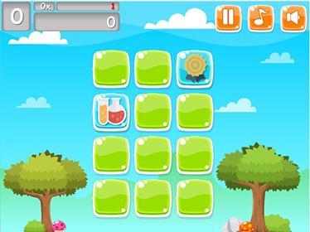Leaderboard: Rank player on theirs score. Score will depend on numbers of game mode, number of cleared cards in a game and extra time.

*Figure 1 a concentration game's variant*

Figure : A Truc xanh's variant

# User Requirements

## Functions

The game consists of a number of cards base on number of rows and columns. When the first and second card are flipped, and if 2 pictures on them are not the same, then after 1 second, they will automatically be folded. Otherwise, if the two images are the same, they will disappear automatically. The game will end when all cards are cleared. The number of cards also increasing along with the difficulty.

## System Requirements

|  |  |
| --- | --- |
| **Hardware Requirement (minimum)** | **Hardware Requirement (recommended)** |
| **+ CPU:** IntelPentium 2 266 MHz  **+ RAM:** 128 MB  **+ Storage:** 128 MB of free disk space | **+ CPU:** Intel Core i9 9900K 3.6 GHz  **+ RAM:** 16 GB  **+ Storage:** 256 GB of free disk space |

|  |
| --- |
| **Software Requirement** |
| + Window XP or higher  + JRE 1.7 or higher |

# Roles

|  |  |  |  |
| --- | --- | --- | --- |
| **No** | **Role** | **Member** | **Responsibilities** |
| 1 | Leader | ThanhKH | Creating Schedule and Check List, Assigning assignment to team members |
| 2 | Secretary | NhanDT | Taking note |
| 3 | Analyst & Design | ThanhKH, NhanDT, BangNT | Table of content, Problem Defining, User Requirement.  Interface Designing |
| 4 | Coder | ThanhKH, NhanDT, BangNT | Programing all functions for applications |
| 5 | Tester | NhanDT, ThanhKH | Testing all functions |
| 6 | Maintenance | NhanDT, BangNT | Checking and backup data |

# Schedule

|  |  |  |  |  |  |
| --- | --- | --- | --- | --- | --- |
| **No.** | **Assignment** | **Member** | **Start Time** | **Estimate time to finish (hrs)** | **Deadline** |
| 1 | Problem Definition | ThanhKH, NhanDT | 20/05/2019 | 4 | 23h50  20/05/2019 |
| 2 | User Requirement and System Requirement | BangNT | 21/05/2019 | 4 | 23h50  21/05/2019 |
| 3 | Analysis | ThanhKH | 22/05/2019 | 12 | 23h50  22/05/2019 |
| 4 | Book cover design  and Group logo design | ThanhKH, NhanDT, BangNT | 23/05/2019 | 12 | 23h50  23/05/2019 |
| 5 | Basic GUI Design | ThanhKH, NhanDT, BangNT | 24/05/2019 | 12 | 23h50  24/05/2019 |
| 6 | Cards & Themes Design | ThanhKH, BangNT | 25/05/2019 | 16 | 23h50  26/05/2019 |
| 7 | Algorithm Diagram | NhanDT | 27/05/2019 | 5 | 23h50  28/05/2019 |
| 8 | Normal Mode & Subclasses Coding | ThanhKH | 29/05/2019 | 24 | 23h50  30/05/2019 |
| 9 | Custom Mode Coding | ThanhKH | 31/05/2019 | 8 | 23h50  01/06/2019 |
| 10 | PlayerManagement Class & Log in Function Coding | NhanDT | 31/05/2019 | 12 | 23h50  01/06/2019 |
| 11 | Leaderboard Function Coding | NhanDT | 01/06/2019 | 12 | 23h50  02/06/2019 |
| 12 | Themes Function Coding & Credits Design | BangNT | 01/06/2019 | 8 | 23h50  02/06/2019 |
| 13 | Detail GUI Design | ThanhKH, NhanDT, BangNT | 02/06/2019 | 24 | 23h50  03/06/2019 |
| 14 | Testing & Debugging | ThanhKH, NhanDT | 04/06/2019 | 12 | 23h50  05/06/2019 |
| 15 | Document Finishing | BangNT, NhanDT | 06/06/2019 | 4 | 23h50  07/06/2019 |
| 16 | Presentation | BangNT | 10/06/2019 | 2 | 12/06/2019 |
| 17 | Implementation | BangNT, NhanDT | 13/06/2019 | 3 | 17h00  13/06/2019 |

# Design Pattern

## Program Interface

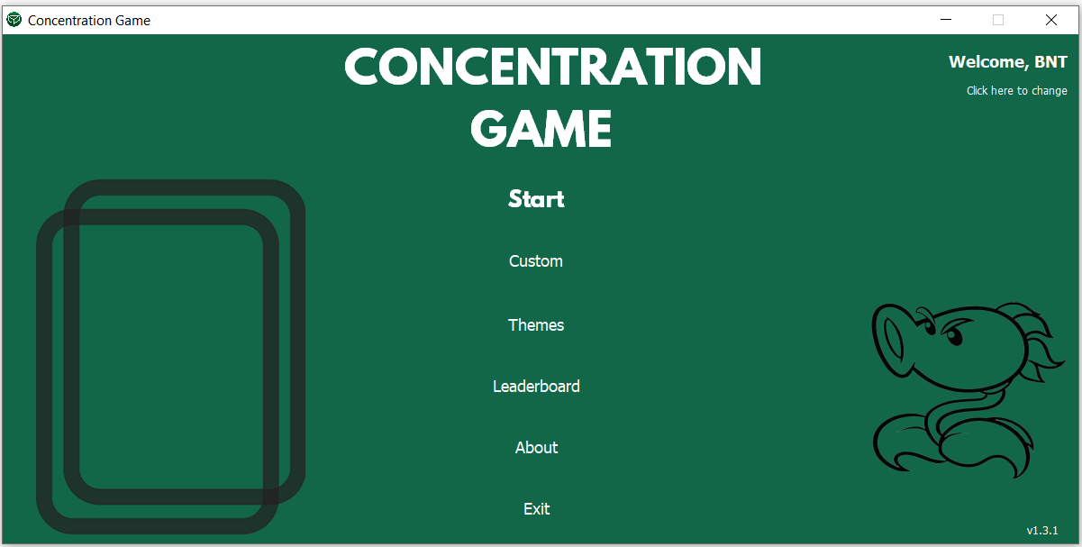

*Figure 3 Main Menu*

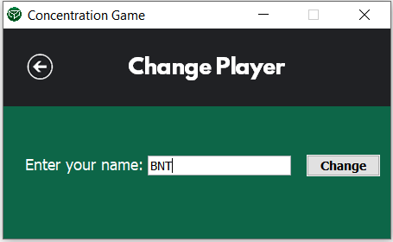

*Figure 4 Log In*

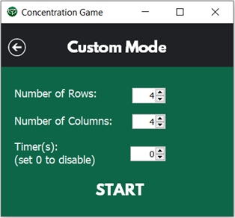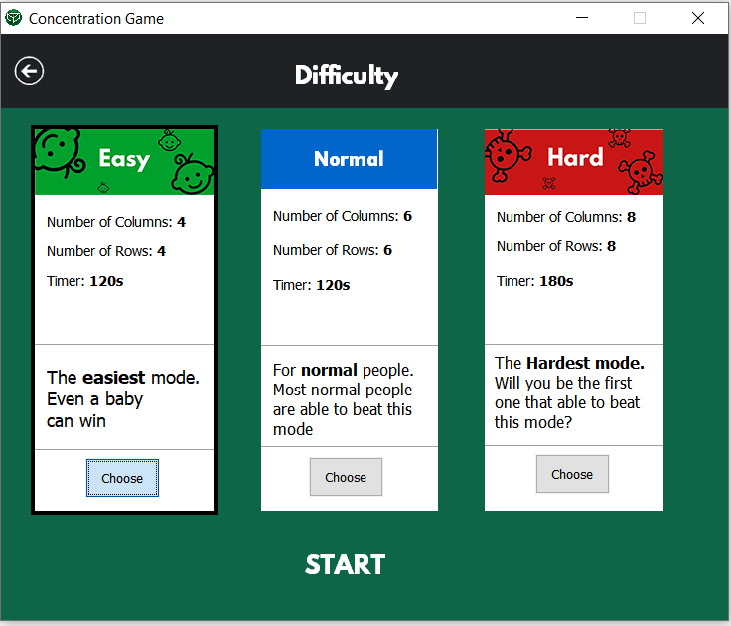

*Figure 5 Difficulty Choosing*

*Figure 6 Custom Mode*

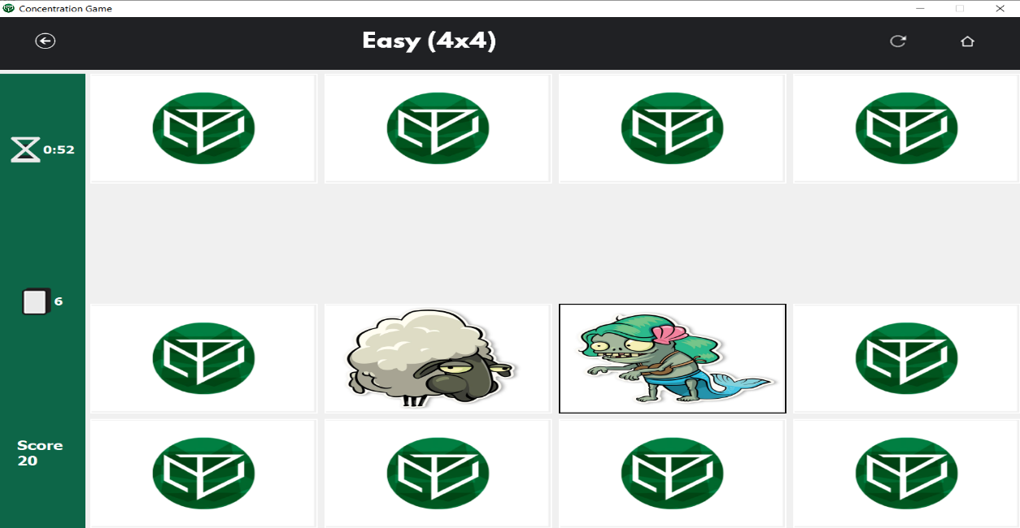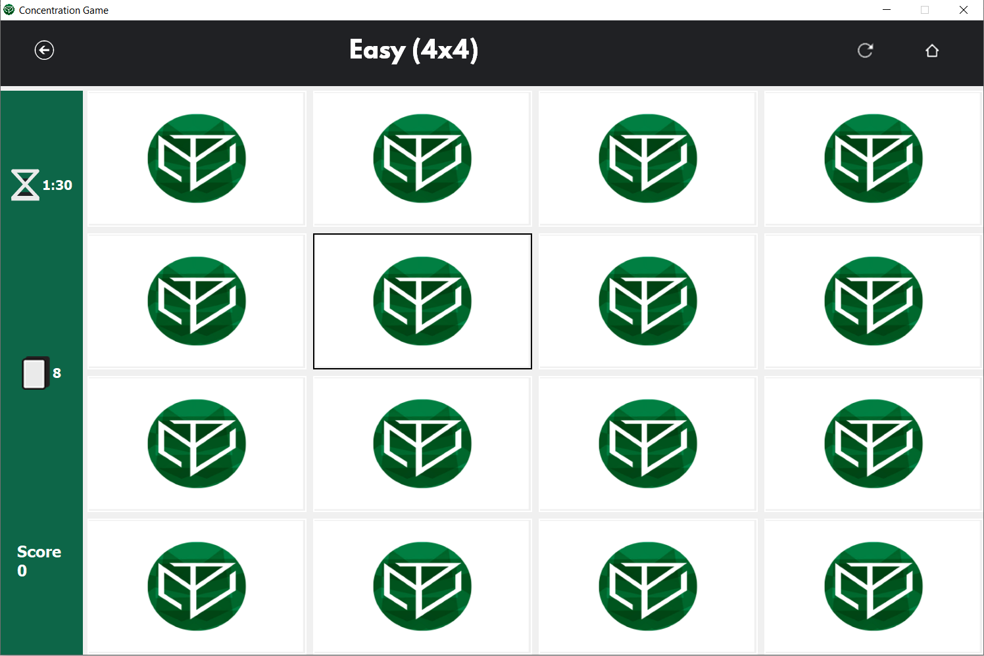

*Figure 7 In-game Interface (2)*

*Figure 6 In-game Interface*

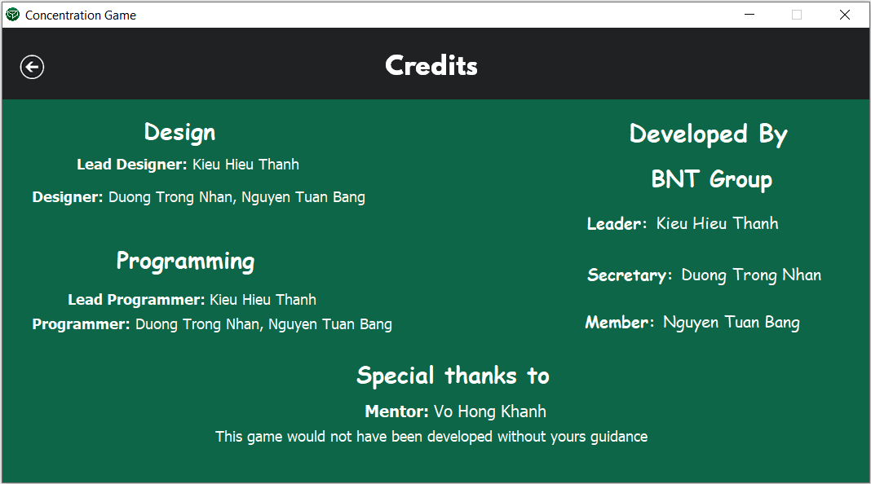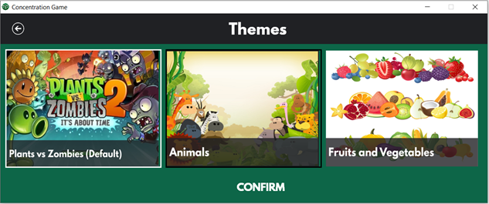

*Figure 8 Themes Manager*

*Figure 9 Credits*

# Execution Flow

## Algorithm Diagram

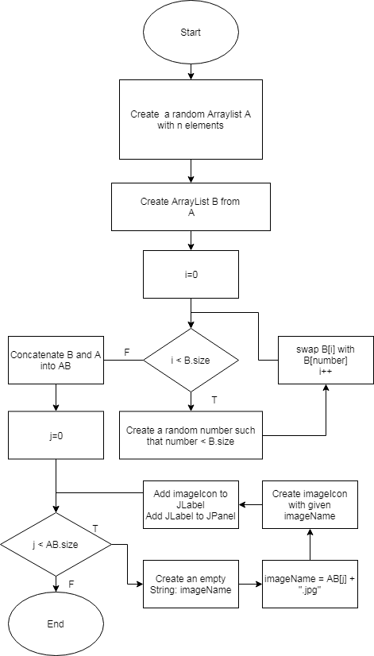

# Maintenance and Updating

Maintenance:

* Offical project will be stored mainly on our group’s chat box on facebook
* We also back up our project to other cloud services like Google Drive, OneDrive every week.
* Functions that are under coding will be stored on group’s members devices.

Updating:

* There are three kinds of update: Big ones, small ones and patches.
  + Big updates: new function(s) or big changes in algorithms.
  + Small ones: include UI update or patches.
  + Patches: bugs fix.
* Our offical project will be updated whenever a new version released.
* New functions will only be added to main project when it’s has been tested carefully by our group’s testers.

# Check List

|  |  |  |  |  |  |  |
| --- | --- | --- | --- | --- | --- | --- |
| **Assignment** | **Member** | **Actual Start Time** | **Estimate time to finish (hrs)** | **Actual End time** | **Work hours** | **Note** |
| Problem Definition | ThanhKH | 13:30  20/05/2019 | 2 | 14:25  20/05/2019 | 1 | Completed |
| Problem Definition | NhanDT | 19:00  20/05/2019 | 2 | 20:00  20/05/2019 | 1 | Review and Modify |
| User Requirement and System Requirement | BangNT | 8:00  21/05/2019 | 4 | 11:00  21/05/2019 | 3 | Completed |
| Analysis | ThanhKH | 8:00  22/05/2019 | 12 | 18:00  22/05/2019 | 10 | Completed |
| Book cover design  and Group logo design | ThanhKH, NhanDT, BangNT | 8:00  23/05/2019 | 12 | 22:00  23/05/2019 | 14 | 2hrs late |
| Basic GUI Design | ThanhKH, NhanDT, BangNT | 8:00  24/05/2019 | 18 | 22:00  24/05/2019 | 14 | Completed |
| Cards & Themes Design | ThanhKH, BangNT | 8:00  25/05/2019 | 16 | 22:00  25/05/2019 | 14 | Completed |
| Algorithm Diagram | NhanDT | 8:00  27/05/2019 | 5 | 12:00  27/05/2019 | 4 | Completed |
| Normal Mode & Subclasses Coding | ThanhKH | 8:00  29/05/2019 | 48 | 23:50  30/05/2019 | 32 | Completed |
| Custom Mode Coding | ThanhKH | 8:00  31/05/2019 | 8 | 14:00  01/06/2019 | 6 | Completed |
| Player Management Class & Log in Function Coding | NhanDT | 8:00  31/05/2019 | 24 | 20:00  31/05/2019 | 12 | Completed |
| Leaderboard Function Coding | NhanDT | 8:00  01/06/2019 | 12 | 8:00  03/06/2019 | 36 | 24hr late |
| Themes Function Coding & Credits Design | BangNT | 8:00  01/06/2019 | 8 | 14:00  01/06/2019 | 6 | Completed |
| Detail GUI Design  (Except Leaderboard) | ThanhKH, BangNT | 8:00  02/06/2019 | 24 | 0:00  03/06/2019 | 16 | Completed |
| Detail GUI Design  (Leaderboard) | ThanhKH, NhanDT | 8:00  03/06/2019 | 4 | 12:00  03/06/2019 | 4 | Completed |
| Testing & Debugging | ThanhKH, BangNT | 8:00  04/06/2019 | 12 | 20:00  04/06/2019 | 12 | Completed |
| Document Finishing | BangNT, NhanDT | 10:00  06/06/2019 | 4 | 12:00  06/06/2019 | 2 | Completed |
| Presentation | NhanDT | 14:00  14/06/2019 | 1 | 14:30  14/06/2019 | 0.5 | Completed &  Presenter changed |
| Implemen-tation | BangNT, NhanDT | 8:00  15/06/2019 | 3 | 10:00  15/06/2019 | 2 | Completed |